06 May 2026  Your Ref:  63 Car Club (Elgin) Ltd  Our Ref:  David Law  Targa/Historic Road Rally event | 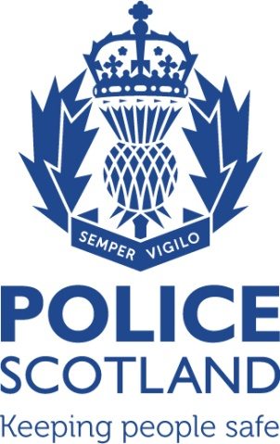  Inspector Susan Taylor  Operational Planning Inspector  Operational Planning  North East Division  Marischal College  Aberdeen  AB10 1AB  101  NorthEastOpsPlanning@scotland.police.uk
Dear Mr Law,

Targa / Historic Road Rally event, Saturday 4 July 2026.

I refer to your e-mail correspondence of 5 May, concerning the above event.

In light of the foregoing, and in terms of Regulation 6 (3) of the Motor Vehicles (Competitions & Trials)(Scotland) Regulations 1976, I can confirm that you have notified the Chief Constable in writing regarding your event and given your assurance as the event organiser/promoter that all vehicles and drivers will comply with all relevant Road Traffic Law and Regulations while they are on the public roads. I can also confirm that we have no grounds for lawful objection to your application.

Checks have been carried out, and I can report that we are aware the Huntly Farmers Market is taking place within The Square, Huntly, same day. This information is only as accurate as the information currently recorded by police and the event organiser must make every reasonable step to avoid conflicts of interest with other event organisers).

I would like to highlight however, that it is your responsibility as event organiser to inform all local authorities on your route and to contact the appropriate roads authority regarding any proposed roadwork’s/road closures that may impact on the event.

In addition I must emphasise that, if the event proceeds it is essential that all participants are reminded of the requirement to comply with all relevant Road Traffic Legislation as well as the advice given in the Highway Code and ensure that no danger or inconvenience is caused to other road users. Notwithstanding, all drivers must also ensure the roadworthiness of their vehicle and that a valid certificate of insurance is in place to cover third party risks.

Yours sincerely
Susan Taylor
Operational Planning Inspector
Police Scotland

